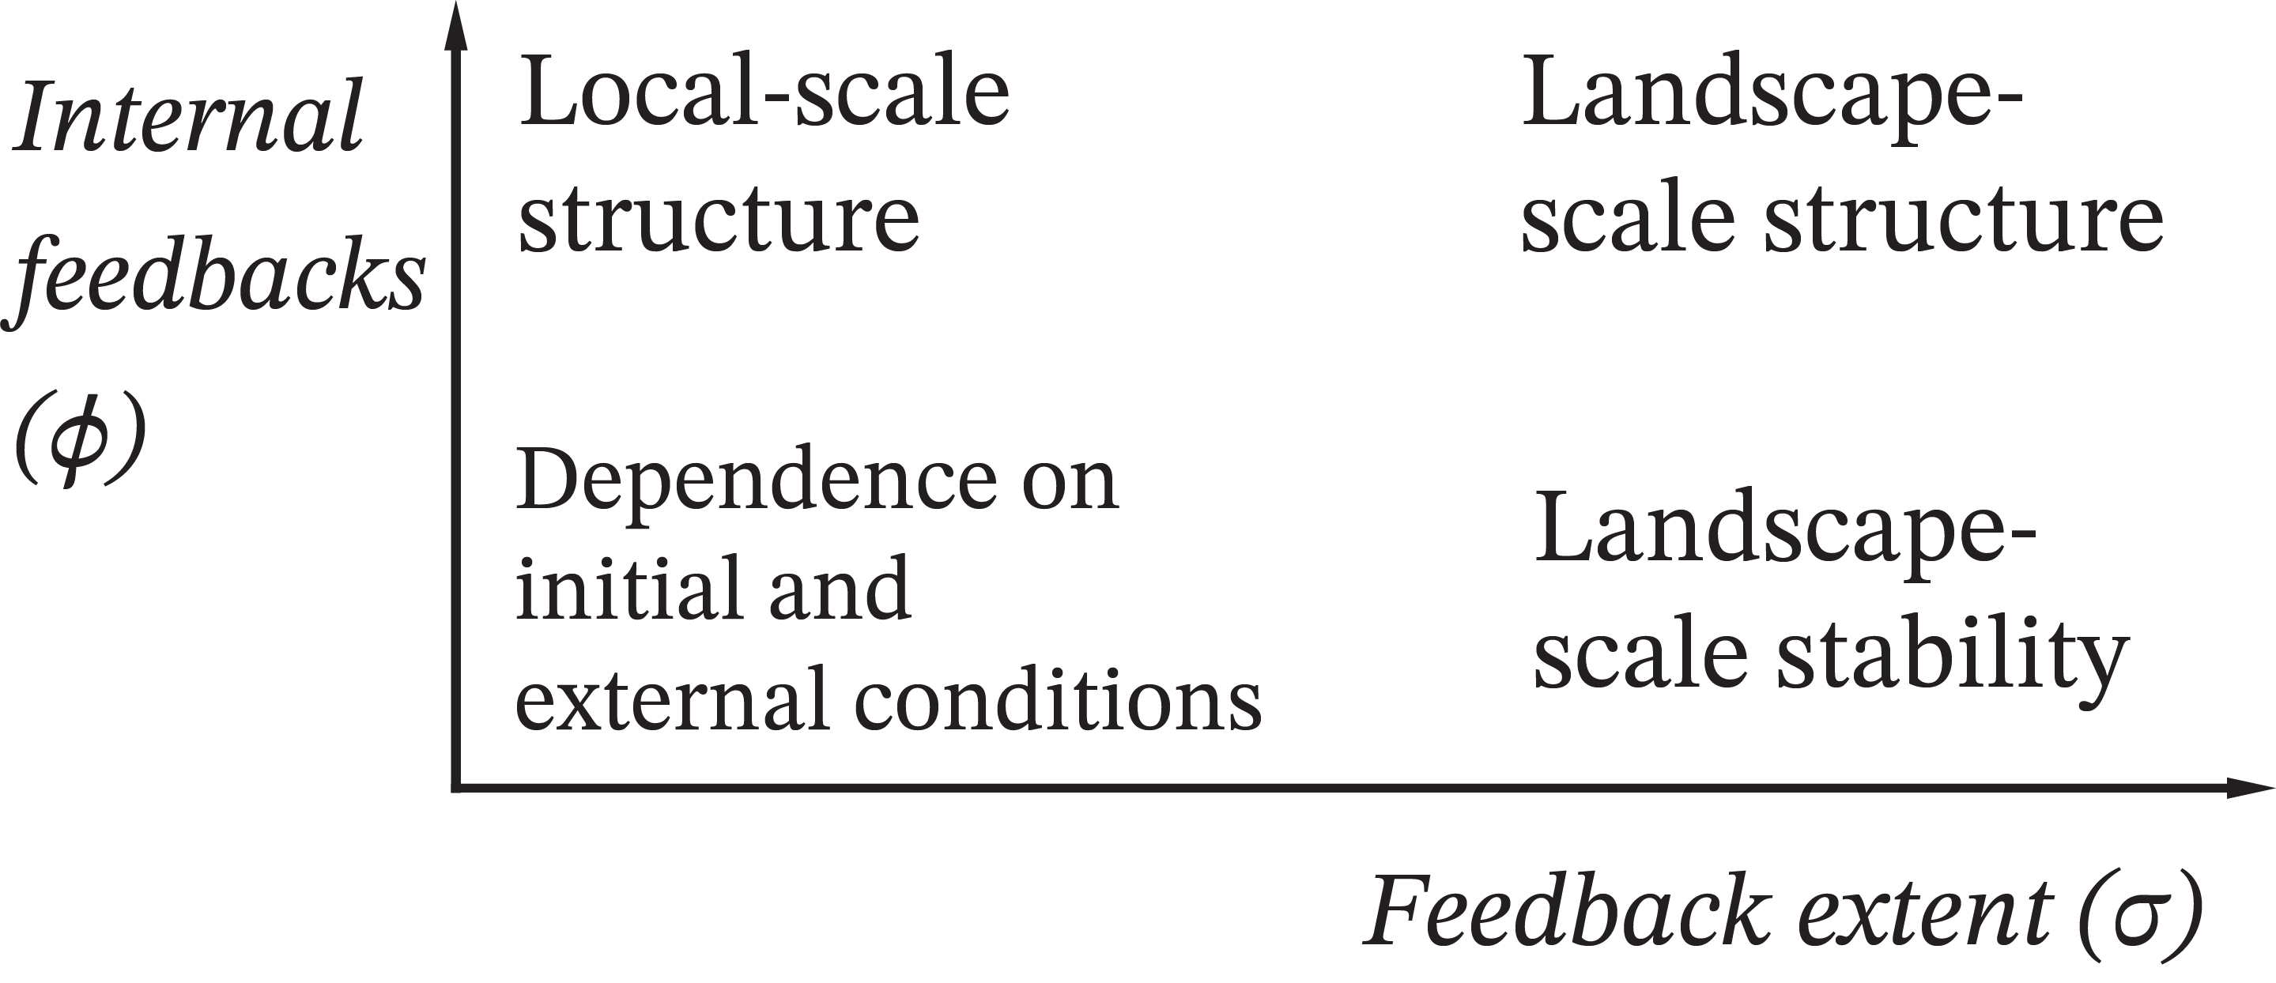

Figure 1: We expect the following dynamics after running the model at varying feedback extents (𝜎) and strengths (𝜙). At low values of both initial conditions are expected to persist, or changes due to external forcings will be purely dependent on them. In the opposite high-𝜎, high-𝜙 quadrant we expect landscapes to exhibit widespread self-organized structure (with *structure* de ined as exhibiting a power-law size distribution.) as internal feedbacks are dominant. At high-𝜎, low𝜙 we expect landscape- wide stability without organization as they are stabilized by long-range feedbacks without strong enough short-range facilitation to lead to structure, and short-range structure without landscape-level effects in the opposite low-𝜎, high-𝜙 corner.

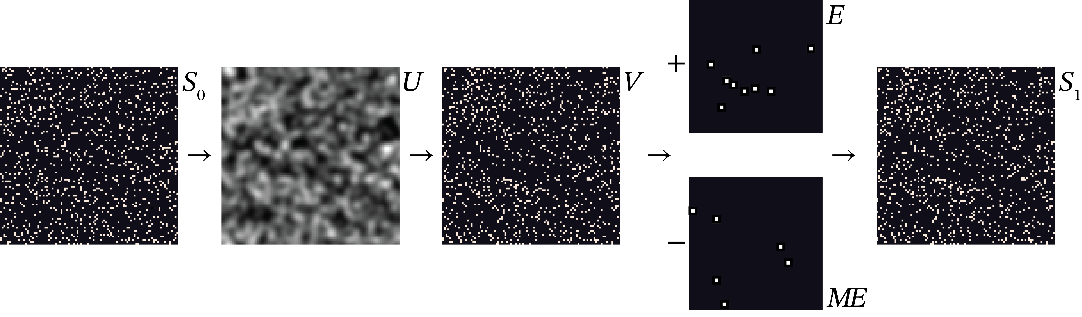

Figure 2: Diagram of model progression over each timestep: moving from 𝑆 to 𝑈 we Gaussian blur the initial state grid at a variance 𝜎. The probability that any given site 𝑥 on 𝑉 will be occupied is given by 𝜙𝑈 + (1 − 𝜙)𝑆 , resolving into values of 0 or 1. Grids randomly generated for establishment 𝐸 and mortality 𝑀𝐸 (with cells magni ied here for demonstration) are then added and subtracted, yielding 𝑆 . Landscapes depicted are 1% as large as landscapes used in mode

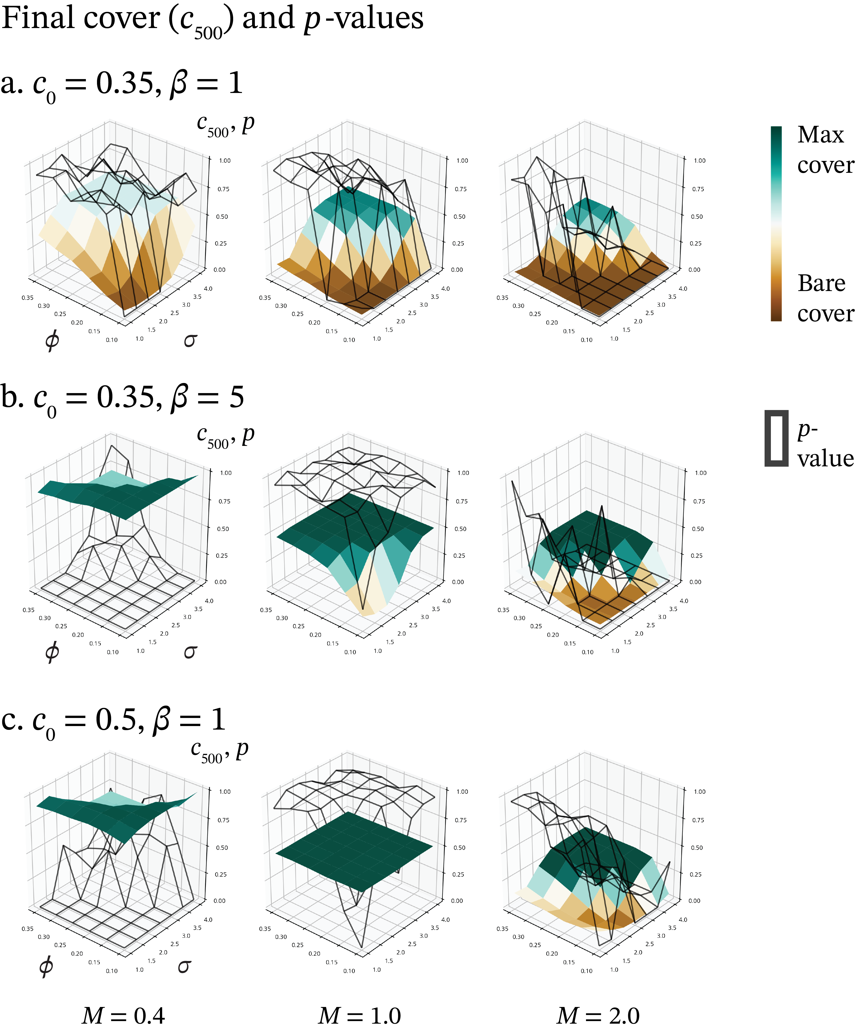

Figure 3: Land cover $c_{500}$ and power law probability 𝑝 for each (𝜎, 𝜙) space, with each (𝜎, 𝜙) surface arranged according to mortality/establishment ratio 𝑀 and rows based on initial starting population𝑐 and outside variability 𝛽; row numbering is consistent across igures (e.g. row a. always describes $c_{0}=0.35, β=1$ in igure 4 as well); $c_{0}=0.5, β=5$ is excluded since it has similar cover dynamics as 𝑐 = 0.5, 𝛽 = 5 and the effects of increasing 𝛽 on clster morphology are similar to 𝑐 = 0.35, 𝛽 = 5 ( igure 5). Since cover in the “high” state is regulated by the overall mortality ratio, the colorbars indicating state are scaled by mortality ratio, not absolute levels of cover. The wireframe surface represents power law probability 𝑝. Note the special case at 𝑀 = 1, 𝑐 = 0.5, 𝛽 = 1 where cover is uniform across the (𝜎, 𝜙) surface but power law probability varies.

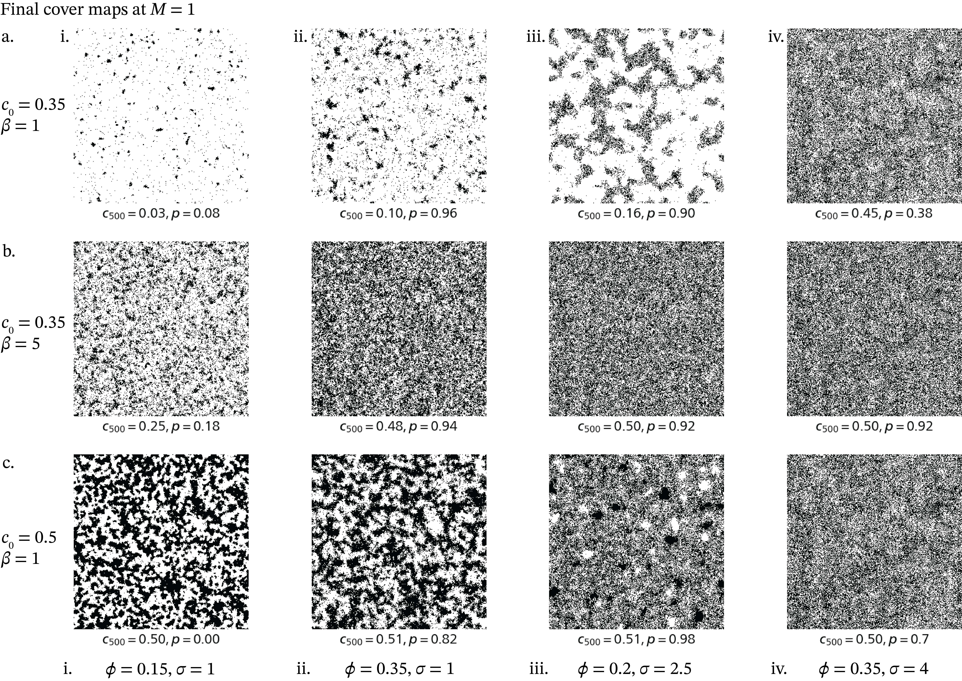

Figure 4: Examples of land cover 𝑐 at 𝑀 = 1 Column i. is the low state at minimal (𝜎, 𝜙). ii. is the intermediate state and minimal 𝜎, maximal 𝜙, iii. an unstable at 𝑡 = 500 state at (𝜎,𝜙) = 2.5,0.2, declining to the low state in row a., increasing to the high state in row b, and in a steady state of cover row c., and column iv. is the high state at maximal (𝜎, 𝜙).

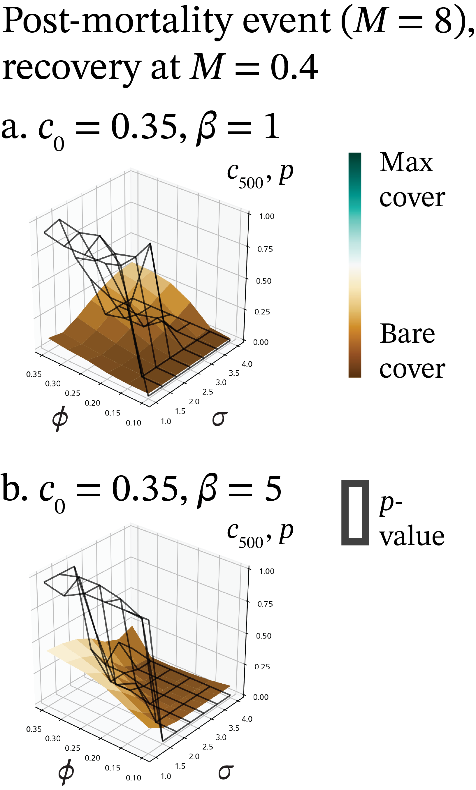

Figure 5: (𝜎, 𝜙) surfaces for land cover $c_{500}$ after a mortality event at 𝑀 = 8 and a recovery condition of 𝑀 = 0.4 for greater clarity of recovery dynamics; similar dynamics are seen at 𝑀 = 1 and 𝑐 = 0.5 and are excluded for conciseness, as are cases when 𝑀 > 1 as they exhibit zero recovery after the mortality event.

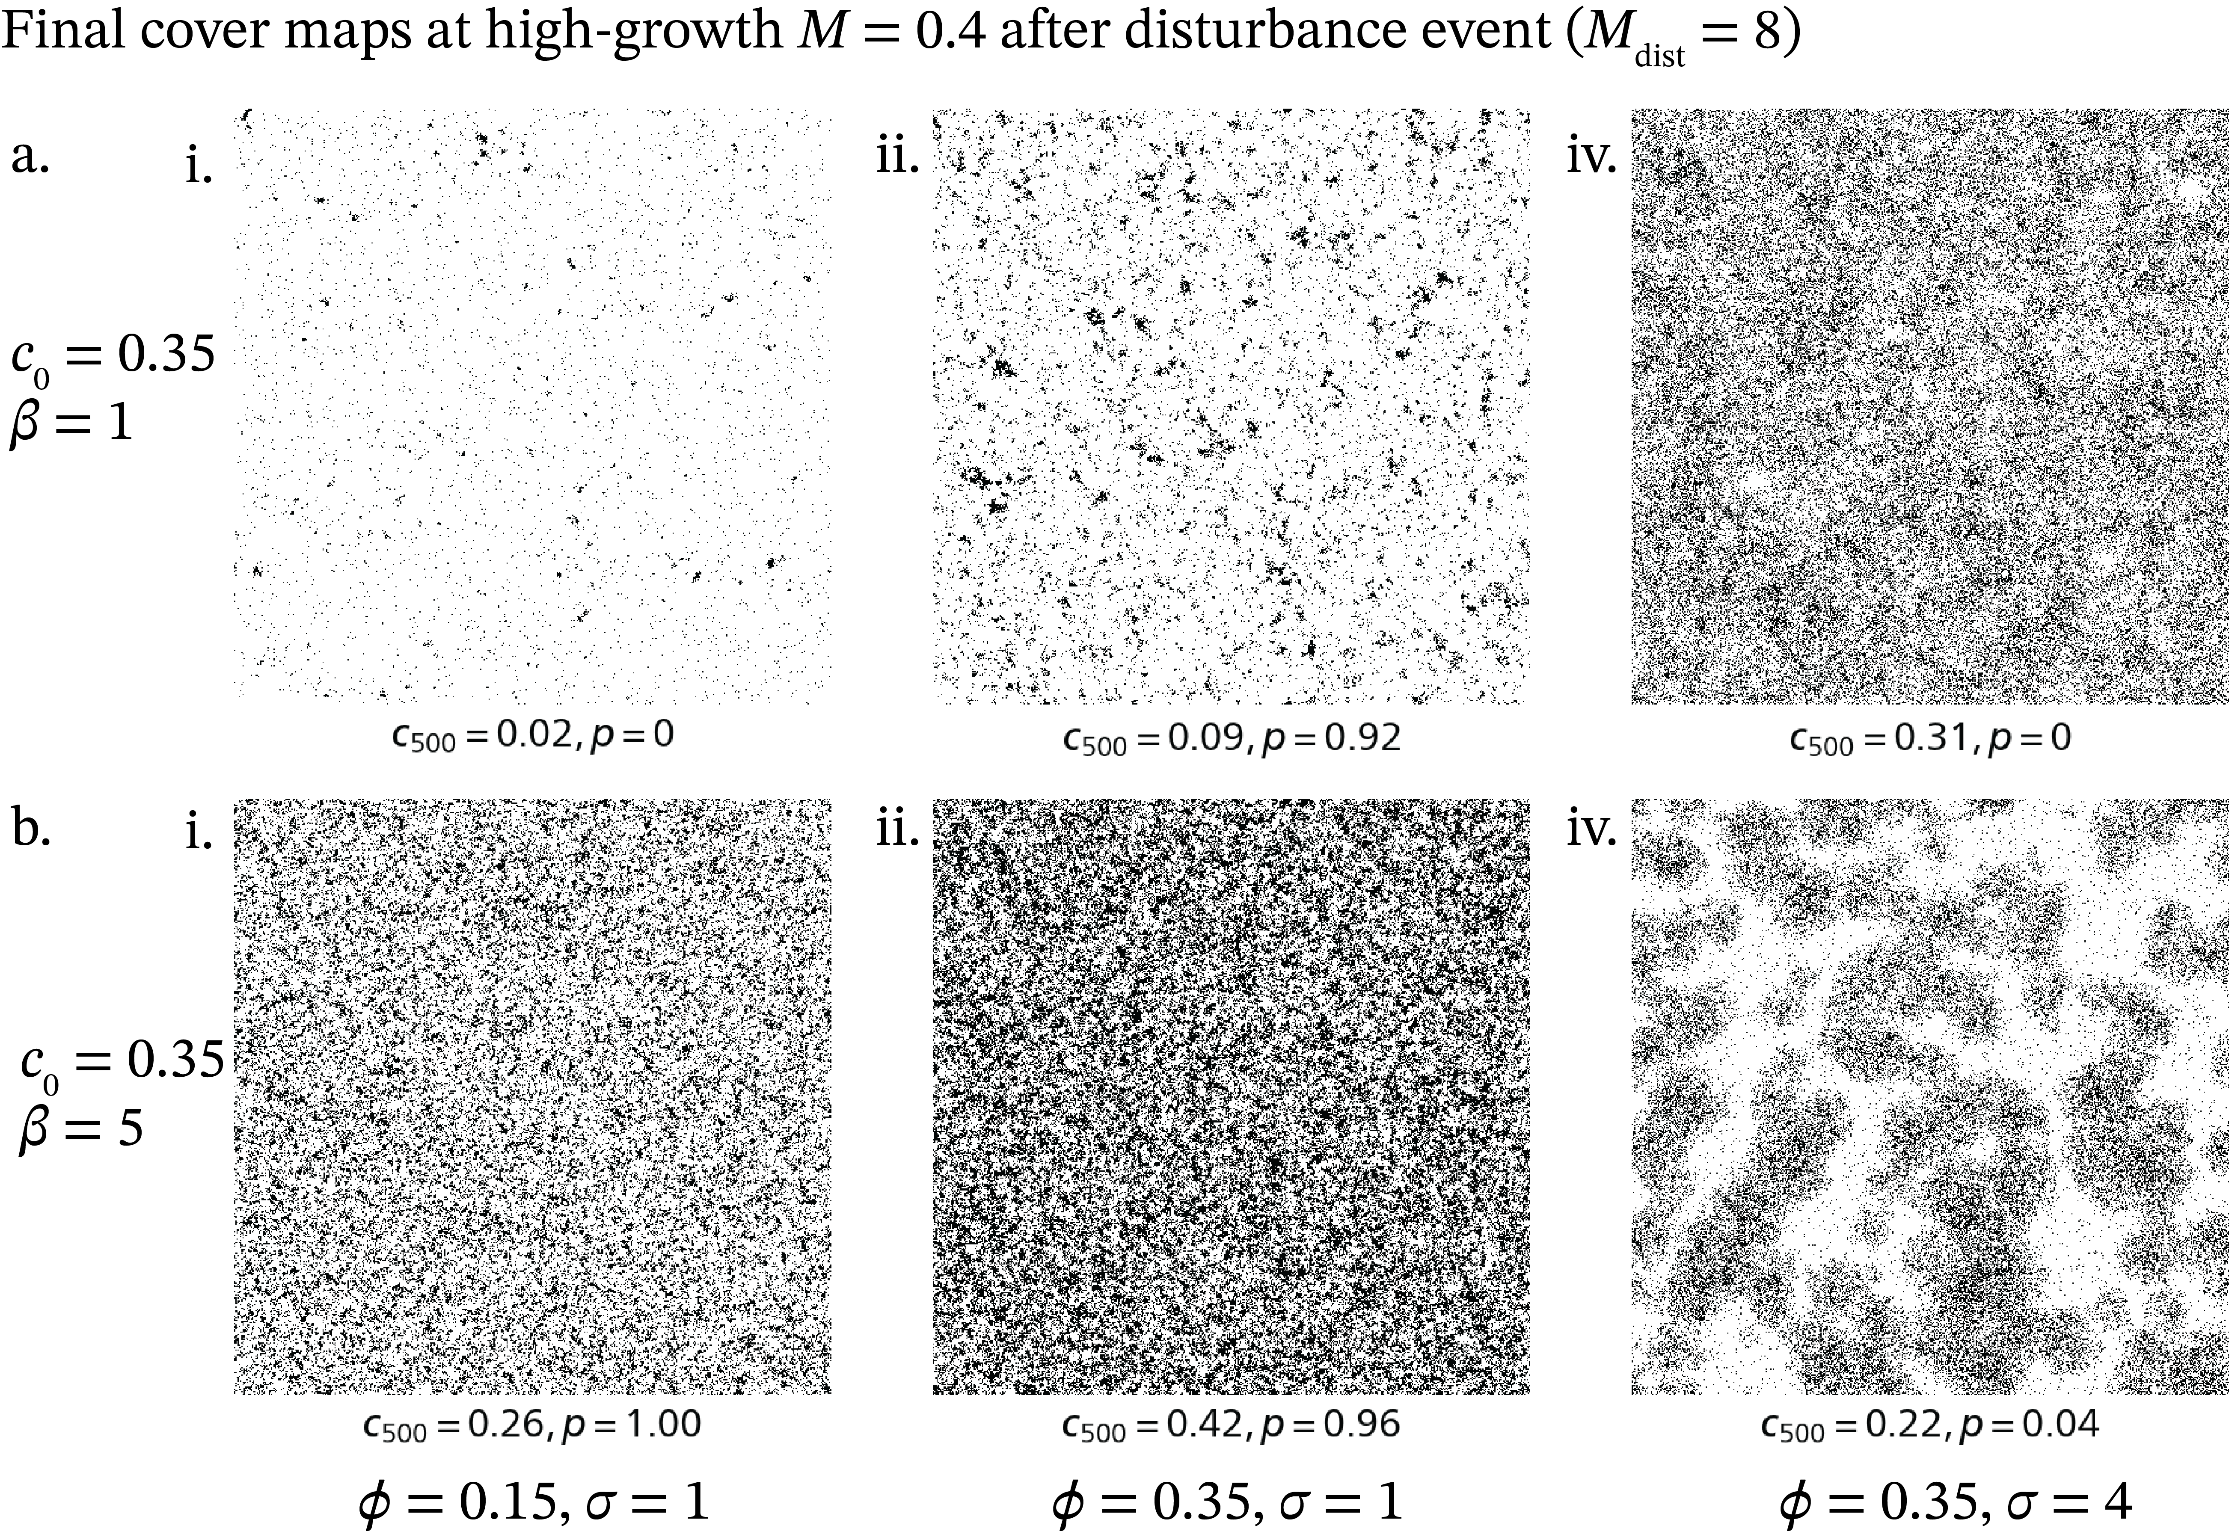

Figure 6: Examples of recovering land cover 𝑐 on the (𝜎, 𝜙) surface after a mortality event at 𝑀 = 8 and a recovery condition of 𝑀 = 0.4 for greater clarity of recovery dynamics. Examples from the middle of the surface ((𝜎, 𝜙) = 0.25, 2.0) are less relevant so column iii. is excluded.

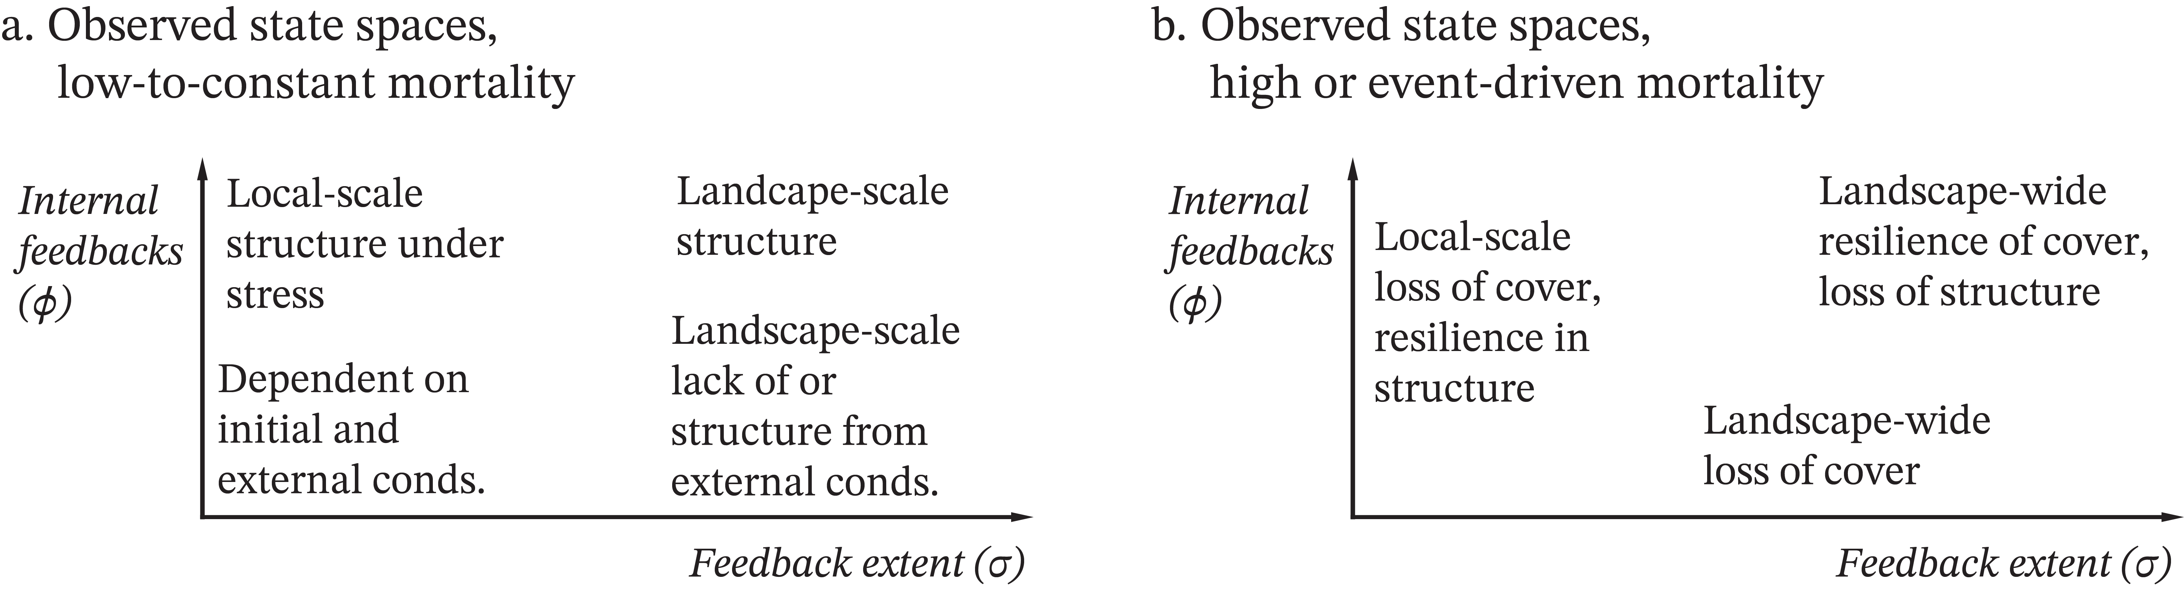

Figure 7: Revising the expected change space in igure 1, in diagram a. we ind a broad similarity with expectations from igure 1 with some revisions. Only the minimal and maximal corners in (𝜎, 𝜙) space consistently manifest. The high 𝜎, low 𝜙 corner can take on the characteristics of either the minimal or maximal corner depending on starting population and outside conditions, with a greater tendency toward the unstructured state. The low-𝜎, high-𝜙 corner only manifests a distinct set of local-scale dynamics under stress, but converging towards the unstructured state when 𝑀 < 1 (figure 3). Under greater stress or after a mortality event the dynamics in structure and cover are often reversed, with some cover remaining at the maximal (𝜎, 𝜙) corner without structure but stronger resilience or growth of locally self-organized cells in the higher-𝜙 area, which lead the recovery of the landscape (figure 5).